HTTP: Hypertext Transfer Protocol
- HTTP was invented by Tim Berners-Lee at CERN in the years 1989–1991.
- It is the underlying communication protocol of World Wide Web.
- HTTP functions as a request–response protocol in the client–server computing model.
- HTTP standards are developed by the Internet Engineering Task Force(IETF) and the World Wide Web Consortium (W3C), culminating in the publication of a series of Requests for Comments (RFCs).
- HTTP has four versions — HTTP/0.9, HTTP/1.0, HTTP/1.1, and HTTP/2.0.
- Now, the version in common use is HTTP/1.1 and the future will be HTTP/2.0.

HTTP/0.9 — The One-line Protocol
- Initial version of HTTP — a simple client-server, request-response, telenet-friendly protocol
- Request nature: single-line (method + path for requested document)
- Methods supported: GET only
- Response type: hypertext only
- Connection nature: terminated immediately after the response
- No HTTP headers (cannot transfer other content type files), No status/error codes, No URLs, No versioning

HTTP/1.0 — Building extensibility
- Browser-friendly protocol
- Provided header fields including rich metadata about both request and response (HTTP version number, status code, content type)
- Response: not limited to hypertext (Content type header provided ability to transmit files other than plain HTML files — e.g. scripts, stylesheets, media)
- Methods supported: GET, HEAD, POST
- Connection nature: terminated immediately after the response

Drawbacks of HTTP/0.9 and HTTP/1.0
- Both HTTP/0.9 and HTTP/1.0 required to open up a new connection for each request (and close it immediately after the response was sent).
- Each time a new connection establishes, a TCP three-way handshake should also occur.
- For better performance, it was crucial to reduce these round-trips between client and server.
- HTTP/1.1 solved this with persistent connections.

HTTP/1.1 — The standardized protocol
- This is the HTTP version currently in common use.
- Introduced critical performance optimizations and feature enhancements — persistent and pipelined connections, chunked transfers, compression/decompression, content negotiations, virtual hosting (a server with a single IP Address hosting multiple domains), faster response and great bandwidth savings by adding cache support.
- Methods supported: GET , HEAD , POST , PUT , DELETE , TRACE , OPTIONS
- Connection nature: long-lived

HTTPS
- Hyper Text Transfer Protocol Secure (HTTPS) is the secure version of HTTP. It uses SSL/TLS for secure encrypted communications.
- Originally developed by Netscape in mid-1990s, SSL (Secure Socket Layer) is a cryptographic protocol enhancement to HTTP, which defines how client and server should communicate with each other securely. TLS (Transport Layer Security) is the successor of SSL.
- An HTTPS connection can protect the data transfer from the man-in-the-middle attacks and common security threats by providing bidirectional encryption for communications between a client and server.
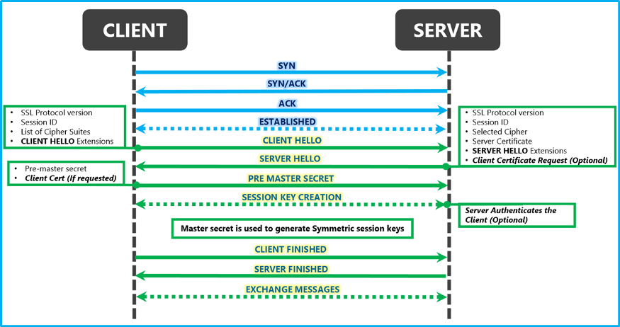
- Although HTTPS is secure by its design, the SSL/TLS handshake process consumes a significant time before establishing an HTTPS connection. It normally costs 1–2 seconds and drastically slows down the startup performance of a website.

HTTP/2.0 and the future
- All above features are being used by major web servers and browsers today.
- But modern enhancements like HTTP/2.0, Server Side Events (SSE), and Websockets have changed the way that the traditional HTTP works.

